**SuperStoreDec2017**

**Data Dictionary**

**JOHN ADRIAN E. ADONA**

*DSA MS SQL MASTERCLASS*

**11 – 11 – 2023**

1. **SuperStoreDec2017**

This is a documentation for **SuperStoreDec2017**, a Microsoft SQL Server database created by John Adrian Adona from a sample Excel data that appears in the December Tableau User Group presentation. This was created for the purpose of project compliance with MS SQL Masterclass training.

The SuperStoreDec2017 database supports store order transaction processing scenarios for Super Store Inc., a fictional store.

You can download the SuperStore Excel dataset here:

* [**Sample - Superstore Sales (Excel).xls**](https://community.tableau.com/s/question/0D54T00000CWeX8SAL/sample-superstore-sales-excelxls)

1. **SuperStore Orders**

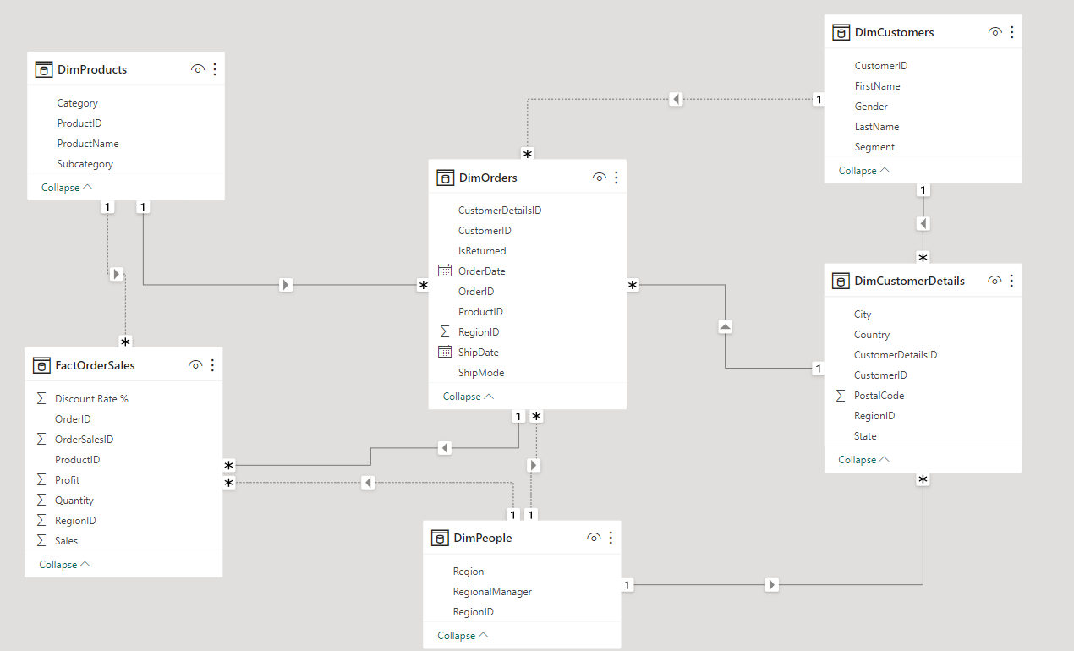

*Orders received and delivered from SuperStore*

1. **Tables**
   1. **Table: dbo.DimCustomerDetails**

Lookup table containing the customers’ detail showing the customers’ location on the date of the order.

***COLUMNS***

|  |  |  |
| --- | --- | --- |
| **Name** | **Data Type** | **Description / Attribute** |
| CustomerDetailsID | int | PRIMARY KEY for the CustomerDetails records Identity / Auto increment column |
| CustomerID | varchar(20) | UNIQUE IDENTIFIER for the Customer records FOREIGN KEY to the DimCustomers table |
| Country | nvarchar(20) | Name of the country |
| City | nvarchar(20) | Name of the U.S. city |
| State | nvarchar(20) | Name of the U.S. state |
| PostalCode | int | Postal code of customer's order location |
| RegionID | int | UNIQUE IDENTIFIER for the Region records FOREIGN KEY to the DimPeople table |

***LINKS TO***

|  |  |  |
| --- | --- | --- |
| **Table** | **Join** | **Title / Name / Description** |
| dbo.DimCustomers | dbo.DimCustomerDetails.CustomerID = dbo.DimCustomers.CustomerID | FK_CustomerDetails_Customers Foreign key constraint referencing DimCustomers.CustomerID |
| dbo.DimPeople | dbo.DimCustomerDetails.RegionID = dbo.DimPeople.RegionID | FK_CustomerDetails_People Foreign key constraint referencing DimPeople.RegionID |

***LINKS FROM***

|  |  |  |
| --- | --- | --- |
| **Table** | **Join** | **Title / Name / Description** |
| dbo.DimOrders | dbo.DimCustomerDetails.CustomerDetailsID = dbo.DimOrders.CustomerDetailsID | FK_Orders_CustomerDetails Foreign key constraint referencing DimCustomerDetails.CustomerDetailsID |

***UNIQUE KEYS***

|  |  |
| --- | --- |
| **Columns** | **Name / Description** |
| CustomerDetailsID | PK_CustomerDetails_CustomerDetailsID Primary key (clustered) constraint |

***USES***

|  |
| --- |
| **Table** |
| dbo.DimCustomerDetails |
| dbo.DimCustomers |
| dbo.DimPeople |

***USED BY***

|  |
| --- |
| **Name** |
| dbo.DimCustomerDetails |
| dbo.DimOrders |

* 1. **Table: dbo.DimCustomers**

Lookup table containing details about the customers’ first name, last name, gender and labeled segmentation.

***COLUMNS***

|  |  |  |
| --- | --- | --- |
| **Name** | **Data Type** | **Description / Attribute** |
| CustomerID | varchar(20) | PRIMARY KEY for the Customer records |
| FirstName | nvarchar(25) | First name of the customer |
| LastName | nvarchar(25) | Last name of the customer |
| Gender | nvarchar(25) | Gender of the customer |
| Segment | nvarchar(20) | Segmentation created to distinguish customer types (Corporate, Consumer, Home Office) |

***LINKS FROM***

|  |  |  |
| --- | --- | --- |
| **Table** | **Join** | **Title / Name / Description** |
| dbo.DimCustomerDetails | dbo.DimCustomers.CustomerID = dbo.DimCustomerDetails.CustomerID | FK_CustomerDetails_Customers Foreign key constraint referencing DimCustomers.CustomerID |
| dbo.DimOrders | dbo.DimCustomers.CustomerID = dbo.DimOrders.CustomerID | FK_Orders_Customers Foreign key constraint referencing DimCustomers.CustomerID |

***UNIQUE KEYS***

|  |  |
| --- | --- |
| **Columns** | **Name / Description** |
| CustomerID | PK_Customers_CustomerID Primary key (clustered) constraint |

***USED BY***

|  |
| --- |
| **Name** |
| dbo.DimCustomes |
| dbo.DimCustomerDetails |
| dbo.DimOrders |

* 1. **Table:** **dbo. DimOrders**

Order date and shipping details as well as lookup table containing other details such as customer details, product details and return status.

***COLUMNS***

|  |  |  |
| --- | --- | --- |
| **Name** | **Data Type** | **Description / Attribute** |
| OrderID | varchar(50) | PRIMARY KEY for the Order records |
| OrderDate | date | Date when the order was booked |
| ShipDate | date | Date when the order was shipped to the customer |
| ShipMode | nvarchar(25) | Shipping type applied to the order (Standard Class, First Class, Second Class, Same Day) |
| CustomerID | varchar(20) | UNIQUE IDENTIFIER for the Customer records FOREIGN KEY to the DimCustomers table |
| ProductID | varchar(25) | UNIQUE IDENTIFIER for the Products records FOREIGN KEY to the DimProducts table |
| CustomerDetailsID | int | UNIQUE IDENTIFIER for the CustomerDetails records FOREIGN KEY to the DimCustomerDetails table |
| IsReturned | nvarchar(10) | Status of order if it is returned or not |
| RegionID | int | UNIQUE IDENTIFIER for the Region records FOREIGN KEY to the DimPeople table |

***LINKS TO***

|  |  |  |
| --- | --- | --- |
| **Table** | **Join** | **Title / Name / Description** |
| dbo.DimCustomerDetails | dbo.DimOrders.CustomerDetailsID = dbo.DimCustomerDetails.CustomerDetailsID | FK_Orders_CustomerDetails Foreign key constraint referencing DimCustomerDetails.CustomerDetailsID |
| dbo.DimCustomers | dbo.DimOrders.CustomerID = dbo.DimCustomers.CustomerID | FK_Orders_Customers Foreign key constraint referencing DimCustomers.CustomerID |
| dbo.DimPeople | dbo.DimOrders.RegionID = dbo.DimPeople.RegionID | FK_Orders_People Foreign key constraint referencing DimPeople.RegionID |
| dbo.DimProducts | dbo.DimOrders.ProductID = dbo.DimProducts.ProductID | FK_Orders_Products Foreign key constraint referencing DimProducts.ProductID |

***LINKS FROM***

|  |  |  |
| --- | --- | --- |
| **Table** | **Join** | **Title / Name / Description** |
| dbo.FactOrderSales | dbo.DimOrders.OrderID = dbo.FactOrderSales.OrderID | FK_OrderSales_Orders Foreign key constraint referencing DimOrders.OrderID |

***UNIQUE KEYS***

|  |  |
| --- | --- |
| **Columns** | **Name / Description** |
| OrderID | PK_Orders_OrderID Primary key (clustered) constraint |

***USES***

|  |
| --- |
| **Table** |
| dbo.DimOrders |
| dbo.DimCustomerDetails |
| dbo.DimCustomers |
| dbo.DimPeople |
| dbo.DimProducts |

***USED BY***

|  |
| --- |
| **Name** |
| dbo.DimOrders |
| dbo.FactOrderSales |

* 1. **Table: dbo.DimPeople**

Lookup table containing labels based on geographical location within United States as well as the person in charge of each region.

***COLUMNS***

|  |  |  |
| --- | --- | --- |
| **Name** | **Data Type** | **Description / Attribute** |
| RegionID | int | PRIMARY KEY for the Region records Identity / Auto increment column |
| Region | nvarchar(15) | Geographic location of within the United State associated with each order's city and state location (West, East, South, Central) |
| RegionalManager | nvarchar(25) | Person in charge of each region category |

***LINKS FROM***

|  |  |  |
| --- | --- | --- |
| **Table** | **Join** | **Title / Name / Description** |
| dbo.DimCustomerDetails | dbo.DimPeople.RegionID = dbo.DimCustomerDetails.RegionID | FK_CustomerDetails_People Foreign key constraint referencing DimPeople.RegionID |
| dbo.DimOrders | dbo.DimPeople.RegionID = dbo.DimOrders.RegionID | FK_Orders_People Foreign key constraint referencing DimPeople.RegionID |
| dbo.FactOrderSales | dbo.DimPeople.RegionID = dbo.FactOrderSales.RegionID | FK_OrderSales_People Foreign key constraint referencing DimPeople.RegionID |

***UNIQUE KEYS***

|  |  |
| --- | --- |
| **Columns** | **Name / Description** |
| RegionID | PK_People_RegionID Primary key (clustered) constraint |

***USED BY***

|  |
| --- |
| **Name** |
| dbo.DimPeople |
| dbo.DimCustomerDetails |
| dbo.DimOrders |
| dbo.FactOrderSales |

* 1. **Table: dbo.DimProducts**

Lookup table containing details about the products involved in the orders made by the customers.

***COLUMNS***

|  |  |  |
| --- | --- | --- |
| **Name** | **Data Type** | **Description / Attribute** |
| ProductID | varchar(25) | PRIMARY KEY for the Products records |
| Category | nvarchar(20) | Segmentation/grouping of products (Furniture, Office Supplies, Technology) |
| Subcategory | nvarchar(20) | Breakdown of products under the product category |
| ProductName | nvarchar(255) | Name of the product |

***LINKS FROM***

|  |  |  |
| --- | --- | --- |
| **Table** | **Join** | **Title / Name / Description** |
| dbo.DimOrders | dbo.DimProducts.ProductID = dbo.DimOrders.ProductID | FK_Orders_Products Foreign key constraint referencing DimProducts.ProductID |
| dbo.FactOrderSales | dbo.DimProducts.ProductID = dbo.FactOrderSales.ProductID | FK_OrderSales_Products Foreign key constraint referencing DimProducts.ProductID |

***UNIQUE KEYS***

|  |  |
| --- | --- |
| **Columns** | **Name / Description** |
| ProductID | PK_Products_ProductID Primary key (clustered) constraint |

***USED BY***

|  |
| --- |
| **Name** |
| dbo.DimProducts |
| dbo.DimOrders |
| dbo.FactOrderSales |

* 1. **Table: dbo.FactOrderSales**

Lookup table containing the quantitative details of the sales made from customer orders and other information.

***COLUMNS***

|  |  |  |
| --- | --- | --- |
| **Name** | **Data Type** | **Description / Attribute** |
| OrderSalesID | int | PRIMARY KEY for the OrderSales records Identity / Auto increment column |
| OrderID | varchar(50) | UNIQUE IDENTIFIER for the Order records FOREIGN KEY to the DimOrders table |
| ProductID | varchar(25) | UNIQUE IDENTIFIER for the Products records FOREIGN KEY to the DimProducts table |
| Sales | money | Amount received from sold product (in dollars) |
| Quantity | smallint | Total number of the product sold |
| Discount Rate % | int | Rate of discount applied on the sold product |
| Profit | money | Total gain/loss received from sales amount of the product, accounting the cost of goods sold |
| RegionID | int | UNIQUE IDENTIFIER for the Region records FOREIGN KEY to the DimPeople table |

***LINKS TO***

|  |  |  |
| --- | --- | --- |
| **Table** | **Join** | **Title / Name / Description** |
| dbo.DimOrders | dbo.FactOrderSales.OrderID = dbo.DimOrders.OrderID | FK_OrderSales_Orders Foreign key constraint referencing DimOrders.OrderID |
| dbo.DimPeople | dbo.FactOrderSales.RegionID = dbo.DimPeople.RegionID | FK_OrderSales_People Foreign key constraint referencing DimPeople.RegionID |
| dbo.DimProducts | dbo.FactOrderSales.ProductID = dbo.DimProducts.ProductID | FK_OrderSales_Products Foreign key constraint referencing DimProducts.ProductID |

***UNIQUE KEYS***

|  |  |
| --- | --- |
| **Columns** | **Name / Description** |
| OrderSalesID | PK_OrderSales_OrderSalesID Primary key (clustered) constraint |

***USES***

|  |
| --- |
| **Table** |
| dbo.FactOrderSales |
| dbo.DimOrders |
| dbo.DimPeople |
| dbo.DimProducts |